phpBB Read History Tracking User’s Guide
Version 1.2 - Draft

Author: Ken Brookman
Last Update: 11/27/02

Synopsis:
This mod allows phpBB to successfully track what threads a user has read, persisting this state between multiple sessions (without cookie dependencies). Each user’s read history is preserved until the user reads the unread thread, or marks it as read.

Purpose:
The mod was created because phpBB’s current implementation of “read history” is not preserved between logins sessions. Once a user has logged out, or has had their session time out, their read history is cleared - flagging all items as “read”.

This is because the phpBB software uses the last login time of the user to generate an “unread” thread list. Problems arise when including an auto-login on the front page of a site, the user’s session times-out (long posts, bathroom breaks, trips to the local ), or not reading all threads in a single sitting.

Usage Statement:
Certainly one of the first questions you should ask yourself is, “Is this mod right for my board?” That question can only be answered by you, but I hope to give you some insight as to whether this mod will make your board more productive or a living hell.

First, consider the implementation of the mod, without the gory details. The implementation tracks all unread posts for every user. This means the more users you have, and the fewer posts that are read by your user base, the larger the read_history table gets. You don’t want your DB tables to get too large, as it can hurt performance, and inflate disk space utilization (which can be $$).

If you have either:
* A very large user base - or -
* A user base that doesn’t read many of the posts, but rather just a few - or -
* A board that has hundreds or more posts a day - then -
...you may want to try the mod on a trail basis and watch the size of the read_history table before committing to using this mod.

An example of where this mod wouldn’t be recommended (in its present state) might be the “phpBB Communities” board (at http://www.phpbb.com). They have a very large user base with hundreds of posts a day, where most users only read one or two posts from the whole board. The read tracking table would quickly inflate, and potentially slow down the whole board.

An example where it might be useful is a board where you have a smaller community, where most people read every post.

If you are in doubt as to whether or not to use the mod, try making a copy of the DB and run with the mod installed for a while (but preserve the old mod-less code). Watch the size of the read_history table and determine if the board’s performance suffers. If the table grows unacceptably or your performance suffers, switch back to your previous install without the mod. Also, you should make sure to read the sections on “Additions” and “Known Issues” to understand what to expect from this mod.

1.0 Using the Mod
1.1 Submitting a post
Post submission works as it always has. The user’s own posts will not show up as new to him/herself.

Technical Details: Each new submission adds an entry to every user’s “unread list” if: 1) they can access the forum being posted to, 2) they are the one writing the post. The submission takes into account the authorization of each member, making sure that only those who have access to the forum get the new “unread” entry.

1.2 Editing a post
Editing a post behaves just as a post submission. The topic will be new to everyone with appropriate access. When clicking on the Newest Topic Flag (see Appendix A) the user’s page will open to the first post in the thread. The user is then responsible for determining which posts have been edited and are new to them (see Known Issues and Additions for more details).

Technical Details: This is handled much the same as the submit. The reason the user is moved to the first reply in a thread when clicking the Newest Topic Flag is a product of the time stamp on different posts.

1.3 Reading a post
Reading posts works as it always has.

Technical Details: Once a user opens a thread, then that thread is marked as read to that user. That thread is cleared from the reader’s unread list in phpbb_read_history table. The user’s read history is cleared upon first view of any page of the thread.

Example: If the user opens a thread that has 12 pages, and only reads the first, though there were 11 more unread pages, the topic is still considered completely read to that user.

1.3 Moving a post
If a post is moved, the shadow topic is not marked as new to anyone. The actual topic, however, is marked as new to everyone who can access the forum to which the topic was moved. When clicking on the Newest Topic Flag the user’s page will open to the first post in the thread (whether it is new or not).

Technical Details: The move uses a delete and re-submit for the topic. This is to perform all the authentication checking again. The post could be moving from a more or less restrictive forum than the one in which it currently resides. This is why the topic now appears new to users. Please see Additions below for possibilities in this area.

1.5 Splitting a post
Splitting a post works just as the Moving a post, expect it only applies to the portions that are split off.

Technical Details: This is handled much the same way as the Move command is. The only difference is the “move” only applies to the individual replies the user has selected.

1.6 Mark all as read
Using the “Mark all as read” link will clear the user’s read history just as before.

Technical Details: The user’s read history is cleared from the phpbb_read_history table.

1.7 Mark all topics read
Marks all the topics in a forum as read.

Technical Details: The user’s read history is cleared for all topics in that forum.

1.8 Using the Newest Topic Flag
This will open the thread to the first post that hasn’t been read by the user. Exceptions to this occur when a thread is new because it has been edited, moved, or split.

Technical Details: The implementation of this uses the post_time in the read_history table. All the post times are compared against the stored “new reply” post time from the read_history table. See Known Issues and Additions below for more.

2.0 Additions to the Mod
2.1 DB Backup and Restore
This mod doesn’t address any backup or restore issues at the moment. Additional work should be done to backup and restore the phpbb_read_history table.

2.2 Initial Creation
This mod doesn’t create the phpbb_read_history table upon initial installation of the phpBB software.

2.3 Search Performance
Many of the queries used by phpBB are in need of optimization. The “View posts since last visit,” which now more properly reads, “View unread posts,” should be able to be optimized since the phpbb_read_history table contains all the information being collected down to post level granularity (using the timestamp).

2.4 User Read Tracking Selection
Additional work might be considered allowing the user to choose the read tracking he/she prefers. The two methods available would be traditional tracking (phpBB’s default) or enhanced tracking (this mod). This would allow users, who are used to or prefer the default phpBB tracking, to see expected results. It would also allow large board to select this mod for a smaller sub-set of its members (like admins and moderators).

2.5 Read History Pruning (Manual)
Additional work is needed to allow users’ read histories to be pruned after a certain time has elapsed. Many boards have users that don’t log in often, and will accumulate a vast read history in a short span of time. This feature would allow the admin to prune all users’ read histories past a certain “expiration” date manually (like a manual prune for topics).

I suggest using a manual query until this feature is available (I am doing it through a cron job that fires nightly right now):
DELETE FROM phpbb_read_history
WHERE post_time < $Your_prune_interval_in_epoch_time

This addition will probably be the first I make to the mod, as it can be most useful and save space in the read_history table.

2.6 Read History Pruning (Automatic)
A pruning feature, set to auto-prune upon user login, could help alleviate some of the problems associated with users who accumulate a large read history. This, like 2.5, will probably be the first addition I make to the mod. It may even go into the mod’s first release, time permitting.

2.7 Allowing Users to Keep Unread Status
Adding the ability to keep a topic as “unread” while viewing a topic, might be useful to some. Many times I read a topic and am not yet ready to comment but don’t want to forget to go back later. This might prove useful for those times.

2.8 Moving and Splitting posts
A addition might be made to the submit function that would distinguish between a move, a split, and a submit. That way admins could chose whether to mark topics that are moved or split as new to users.

2.9 Editing Posts
Additional work might be considered that would open the user’s page to the edited post when the Newest Topic Flag is clicked (see known issues for comments about highlighting).

3.0 Known Issues
3.1 The new icon flag (highlighting) while viewing a topic
Once a user clicks on the Newest Topic Flag, he/she is usually brought to the first post that he/she hasn’t read. This will still be true with this mod. The highlighting should be “on” or “new” for all the topics that haven’t yet been read while the old topics should remain un-highlighted. The issue arises when the user spans multiple pages of new topics or doesn’t go to the first new topic right away. Since the user’s read history is cleared when the user opens the first page of the thread, any additional pages in that thread will be un-highlighted (see Appendix A for an example of the Highlight Flag).

An example might help clarify:
Scenario:
Sue sees that there is a thread with 6 pages. The topic is showing that there are new posts.

Issue:
Sue opens the first page of the six page post. All the replies are un-highlighted because the first new reply to her is on page 4. When Sue opens page 4 now, all the topics still show as un-highlighted. That is because Sue’s read history for this thread was cleared when she opened page 1.

Work Around:
Use the Newest Topic Flag to go to the first new post. As long as you open the thread to the first new unread reply, highlighting will work. Any successive pages will not be highlighted, however.

Exposure: The issue is small, in my opinion, and wasn’t worth trying to fix in this release. It is a minor inconvenience when trying to determine where to pick up reading a thread. Many users are unaware of the highlighting anyway.

  - Next/Previous Topic Mod
This mod is known to interfere with the operation of the Next/Previous topic mod which replaces the “View Previous Topic :: View Next Topic” with the topic subject and appropriate Read/Unread tag. Although both mods will continue to function correctly, the Read/Unread tags may show incorrectly depending upon the user’s viewing actions.

4.0 Definitions
category - this is a grouping of different forums. These are displayed on the first page of the board.

forum - this is a collection of threads. These list of forums are displayed on the first page of the board.

phpbb_read_history table - this is the table that is used to store the read history tracking with in the database

reply/replies - this is the individual text messages in a thread

thread - this describes a whole subject. One entry in a forum.

topic - same as a thread

Appendix A:
Graphically defining terms.

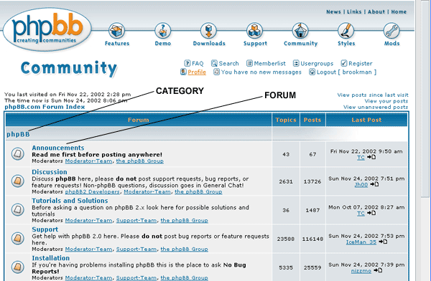

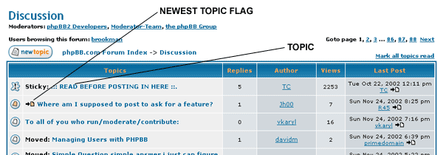

Highlighting - Please note that the New Icon (below) should appear as orange or “highlighted” in some way, whereas the Not New Icon will appear as white or “un-highlighted”.

